1. Design DFA to accept bcaaaaaaaaaaaaaa, bc, and c

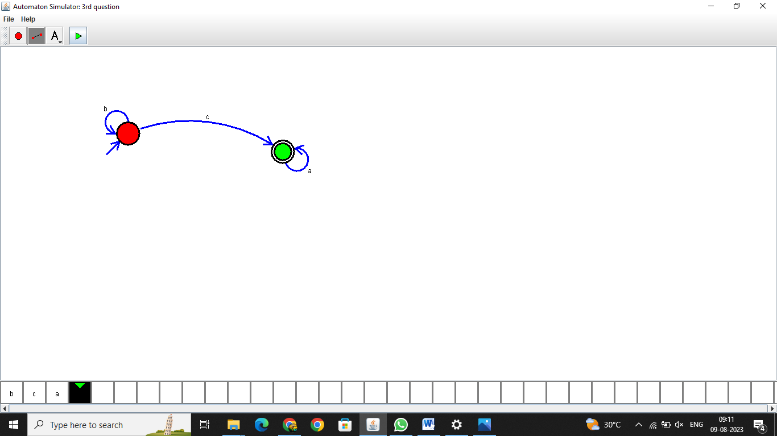

O/P: Hence verified the program is running successfully

2.Design NFA to accept aaaaaa

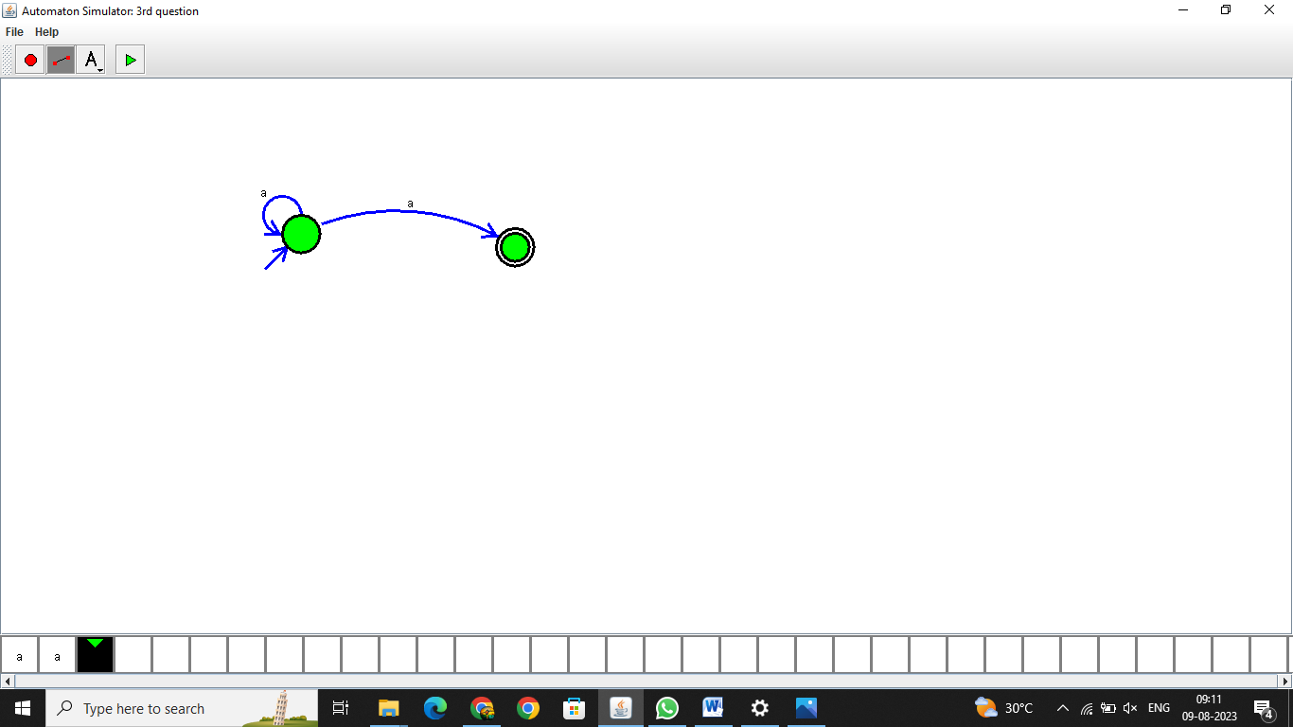

O/P: Hence verified the program is running successfully

3.Design PDA for the input a^nb^n

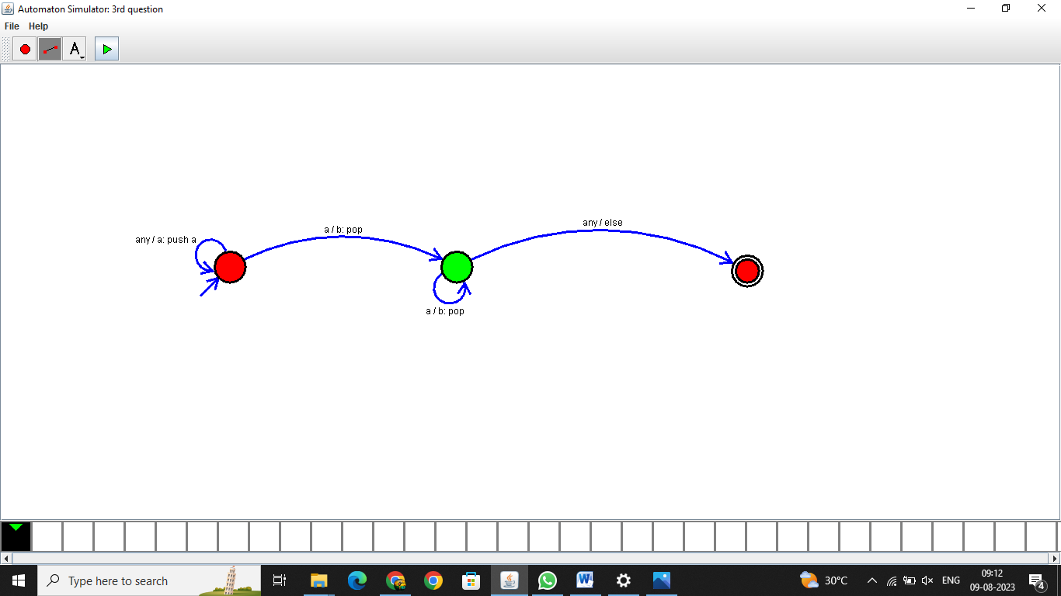

O/P: Hence verified the program is running successfully

4.Design Tm For input a^nb^n

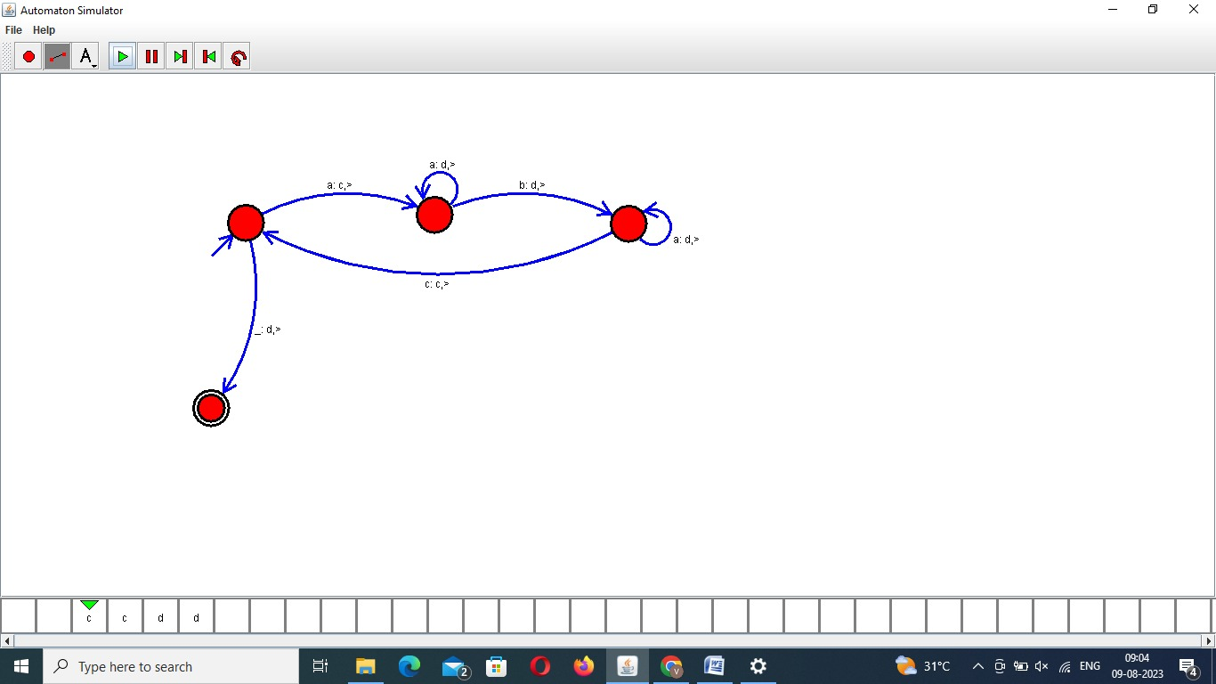

O/P: Hence verified the program is running successfully

5 .Design PDA for input aabbbbc ( L=a^nb^2n)

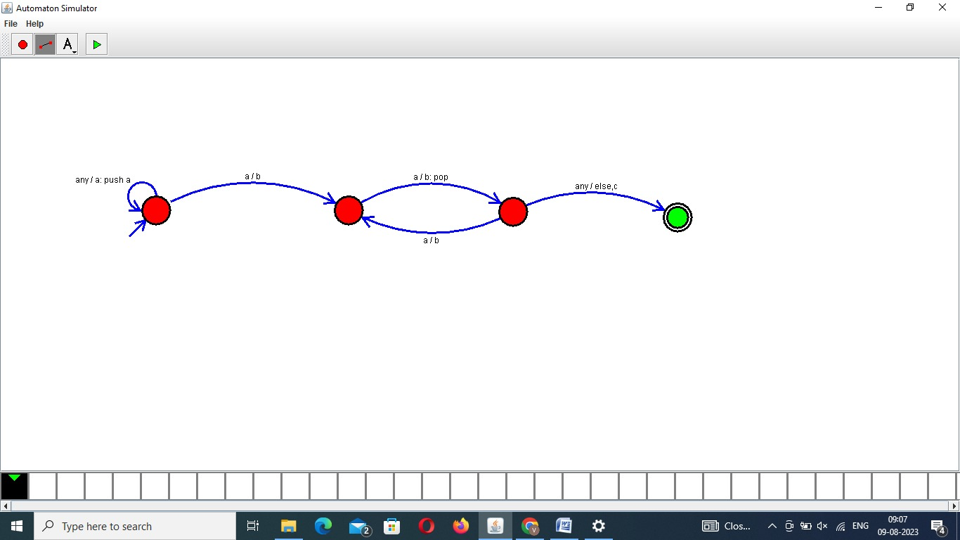

O/P: Hence verified the program is running successfully

6.TM Simulation for Palindrome W= ababa c

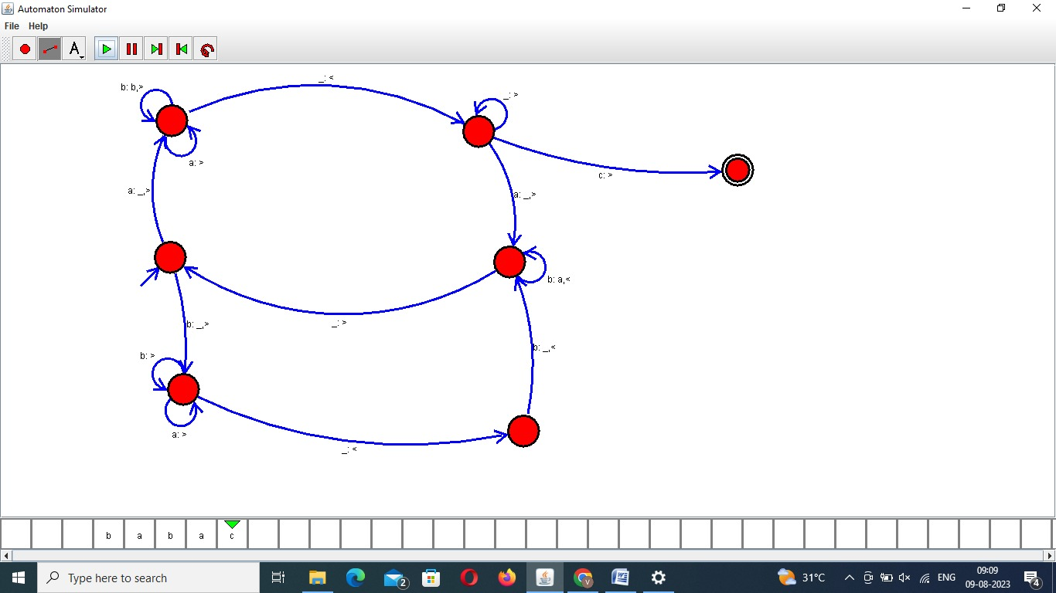

O/P: Hence verified the program is running successfully

7.Design TM to perform addition of following

W= aa + aaaa

After Addition of a’s = aaaaaa

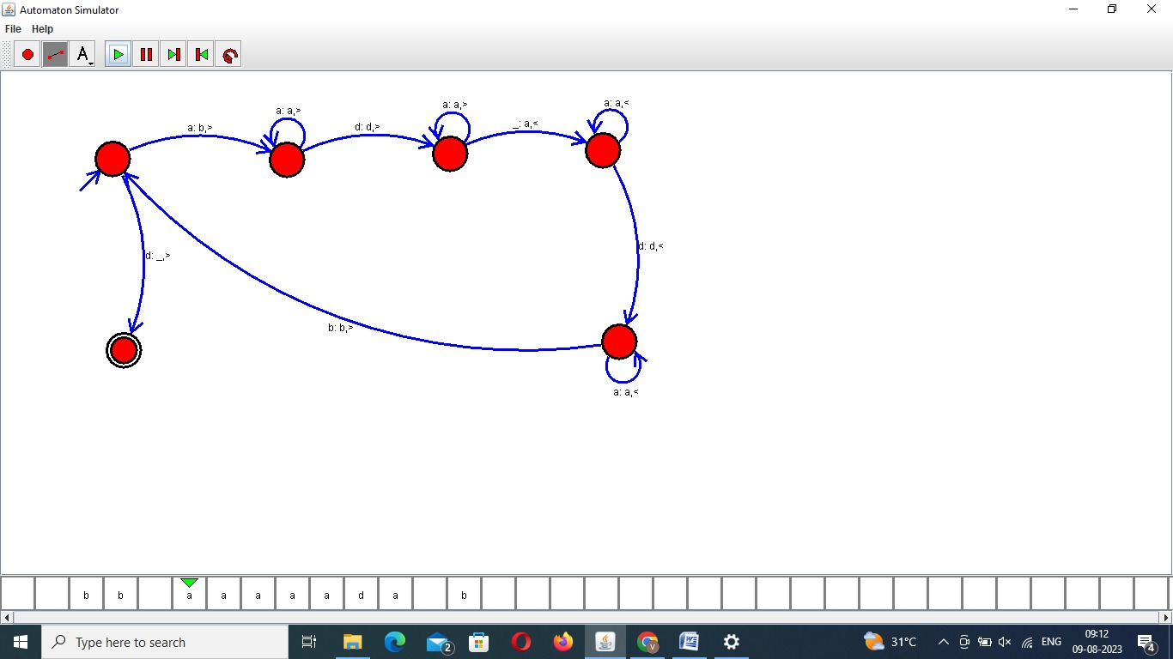

O/P: Hence verified the program is running successfully

8.Design TM to perform subtraction

W= aaa-aa

The Result of Subtraction is = a

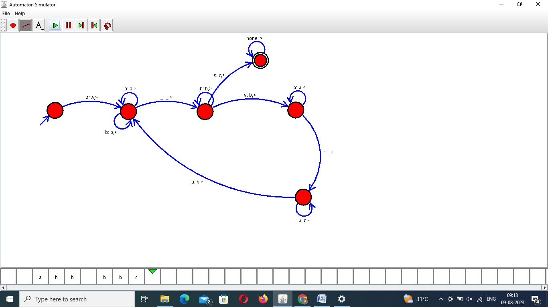

O/P: Hence verified the program is running successfully

9.Design TM to perofrm string comparison

W = aba aba

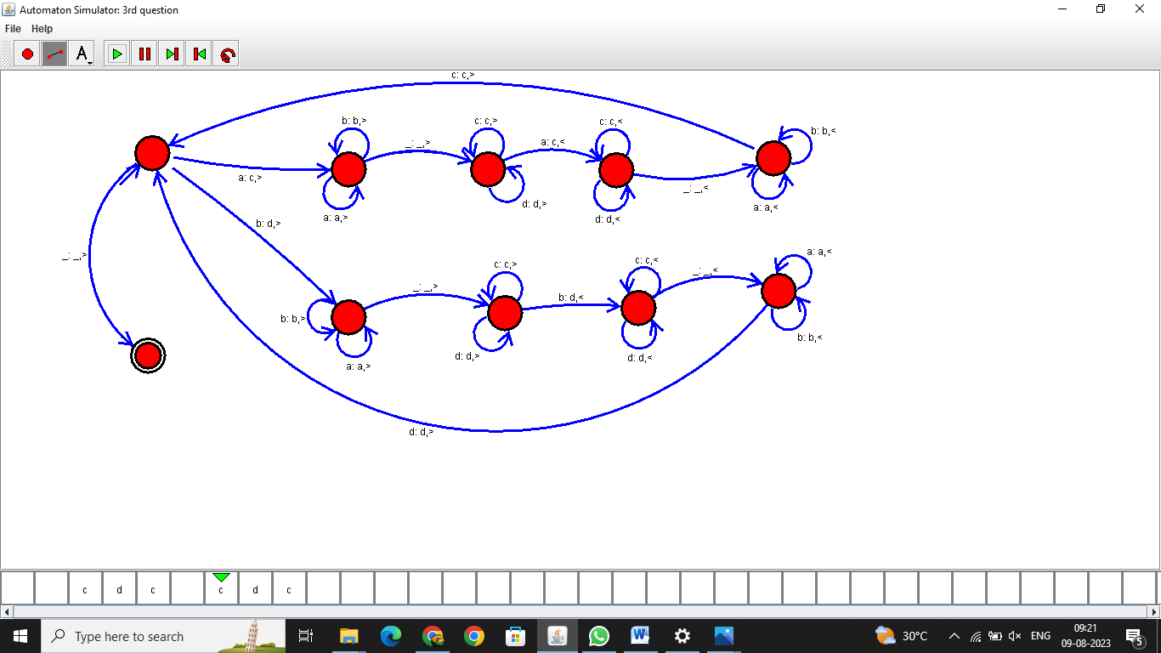

O/P: Hence verified the program is running successfully